# ShopNest Store Sales Analysis Dashboard

1. Top Categories by Total Price:
   * Identify and visually represent the top 10 product categories by total sales.

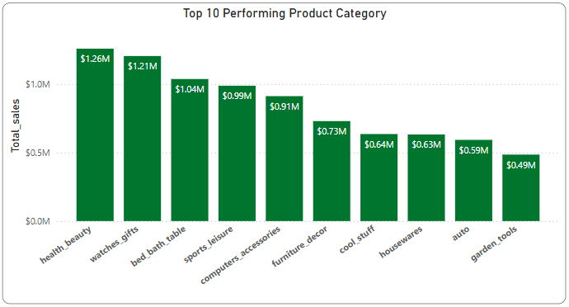

The visualization shows the split of top 10 products by sales (Total Sales is defined as Price*No.of quantity sold or the order count as no extra column of quantity is present)

*\*All the data those are missing Product category are filtered out*

**Insights:**

Total number of products 71.

Top 10 Product Categories contributes up to ~62.5% of the total sales.

‘Health Beauty' being the highest contributor ~10% of overall sales

1. Delayed Orders Analysis:

* Determine the number of delayed orders in each category. An order is considered delayed if the actual delivery date is later than the estimated delivery date.

The above bar chart decribes the number of orders are being delayed while delivering in each category

*\*All the data those are missing Product category are filtered out*

**Insights:**

Total number of delayed orders is 6,535 orders with an average delay of 10.62 days

‘Bed Bath Table’ category has the most number of delayed orders

Where as Music, art and craftmanship, fashion sports and flowers have the miniimum

1. Monthly Comparison of Delayed and On-Time Orders:

* Create a dynamic visual that compares the number of delayed orders to the number of orders received earlier for each month.
* Utilize the drillthrough cross-report feature to provide a detailed analysis of late and on-time deliveries.

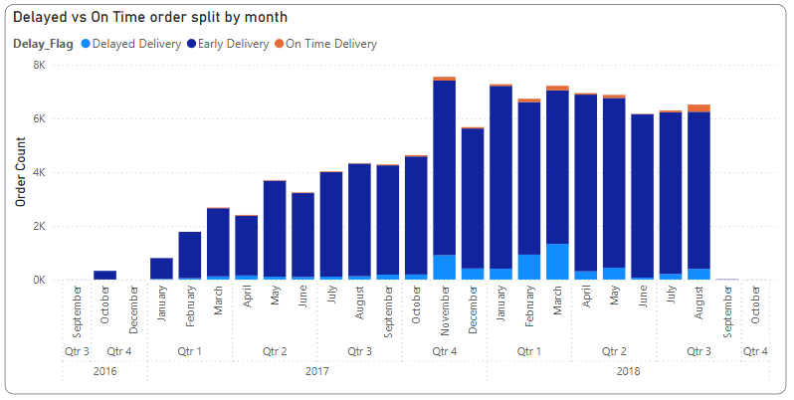

Calculated the number of delayed orders and Early/On Time Orders from the order table to generate the following visual showing the longitudinal behaviour of delayed orders vs Early/On time Orders

Added an extra drill through page to do deeper analysis on product category level and Order Status level

**Insights:**

March,2018 has the maximum number of orders to get delayed with 1,328 orders delayed in total(~20% of overall delayed orders)

Health and Beauty and Bed/Bath/Table being the most delayed products during this month

1. Payment Method Analysis:

* Analyze the most frequently used payment methods by customers using a visually appealing representation, such as a pie chart or other suitable visuals.

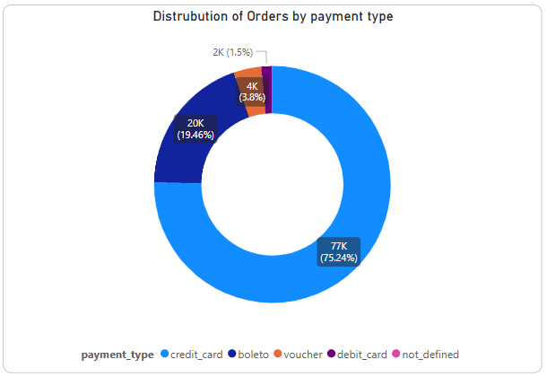

Visualized the percentage contibution of each payment type used during payment of the orders using Order payment table

**Insights:**

Out of 99,441 orders 76,505 orders are payed using ‘Credit Card’ which contributes ~75% of the overall payment type and the second most used payment method being ‘Boleto’ with ~19% contribution

1. Product Rating Analysis:
   * Determine the top 10 highest-rated products and the bottom 10 lowest-rated products using a bar or column chart.

Leveraging the Order review table and review column calculated the average rating of each orders then joineed the table with the product category to get the respective category of those orders

*\*All the data those are missing Product category are filtered out*

**Insights:**

CDs/DVDs/Musicals are the highest rated product with 4.67 mean rating

Security and Services is the lowest rated product with 2.5 mean rating

1. State-wise Sales Analysis:
   * Identify and visually represent states with high and low sales, providing a clear understanding of regional sales performance.

Utilised column chart to visualize the top/bottom 10 performing states by sales. A drilled through analysis is also carried out to find the best performing cities in each state as well

*\*All the data those are missing State information are filtered out*

**Insights:**

SP (‘São Paulo’) is the best performing state with over $5M worth of sales

RR (‘Roraima’) is the least performing state with only $8K worth of sales

1. Seasonal Sales Patterns:

* Investigate and visualize any seasonal patterns (Quarterly) or trends in sales data over the course of the year.

Created two different form of seasons using DAX Query, one Quarters where each quarter contains 3 month starting from January, Feburary and March respectively and also created a specialised season column which is described below

*\*Summer season includes April, May and June, Rainy season incudes July and August, Falls include September and October and Winter includes November, December and January*

**Insights:**

There is a constant growth in the sales figure quarterly from Q1,2017 to Q2,2018 then there is a sharp drop in sales in Q3,2018

Utilizing Seasons Summer season is the most profitable season for the Store with maximum sales where as during Autumn the sales dry up

1. Revenue Analysis:

* Determine the total revenue generated by ShopNest Store and analyze how it changes over time(Yearly). Represent this information through suitable visuals to highlight trends and patterns

Calculated the total revenue generated by sales of products without incorporating the freight price which can be simply done my modifing the total sales DAX column from:

Total_sales = sum(Order_items[price])

To

Total_sales = sum(Order_items[price]) + sum(Order_items[freight value])

**Insights:**

The growth from Q4 2016 to Q1 2017 is the highest with sales rising by ~1400%

By the time Q3 2018 came the sales dropped by ~39% in that perticular quarter when compared to the previous quarter

**Additional Information:**

Slicers are added to the main visual as well as all the other pages for quick filteration of the data based on Year, Product Category and State

All the visuals are seperately calculated in different sheets to get better understanding to the question and to do deeper analysis of those questions

“Delayed vs On-Time order split” and “Top 3/Bottom 3 State by Sales” visuals incudes Drill through features to deepdive into the data